# Proposal

**Hunger Mate**

Christopher Mendoza

Haricharan Mukthineni

Gabriel Braun

## UNIVERSITY OF HOUSTON CLEAR LAKE

4/4/2024

## Table of Contents

Introduction …………………………………………………………… 3

Statement of the Problem …………………………………………………………… 3

Research Questions …………………………………………………………… 3

Intent of the Study …………………………………………………………… 5

Methodology …………………………………………………………… 6

Timeline ……………………………………………………………6

References …………………………………………………………… 7

## List of Tables

Table 1. Description of Attributes in Restaurant table ……………………………….3

Table 2. Description of Attributes in Order table ……………………………………4

Table 3. Description of Attributes for Menu Table……………………………………..4

Table 4. Sample Data for Restaurant Table…………………………………………….4

Table 5. Sample Data for Orders Table…………………………………………………5

Table 6. Sample Data for Menu Table………………………………………………….5

## List of Figures

Figure 1. Jira Timeline showing Scrum Sprints ……………………………………………7

## Introduction

For this project, we have been tasked with creating a command line application that allows users to place a food order from a restaurant. This application will allow users to filter their selections based on the culture of the food such as Chinese, Mexican, Indian, etc. Customers will then be allowed to customize their food, choose a delivery method, and finalize their order with their payment information. The orders received will be stored in a MySQL database. This project proposal outlines the design and development of a user interface that makes use of database integration and agile approaches to give users a customized and dynamic experience.

## Statement of the Problem

Today, about 60% of consumers in the U.S. order delivery or takeout once a week. Digital Ordering has grown over 300% faster since 2014. A lack of an online ordering service leads to a restaurant losing potential sales because the customer might decide to go somewhere else if they don’t have the convenience of ordering online. We will be implementing an application that addresses food customers' needs of having access to online ordering.

## Research Questions

* Does this app provide ease of use?
* What features or services do customers value most in an online food ordering platform?
* How do existing platforms differentiate themselves, and what opportunities exist for innovation?

| Attributes | Data Type | Example Values |
| --- | --- | --- |
| RestaurantID | Int | 1 |
| RestaurantName | String | “McDonalds” |
| RestaurantType | String | “Chinese “ |

Table 1. Description of attributes for Restaurants Table

| Attributes | Data Type | Example Values |
| --- | --- | --- |
| OrderId | Int | 123 |
| CustomerName | String | “Chris Mendoza” |
| Customizations | String | “No Onions” |
| OrderTotal | Float | “12.50” |
| DeliveryInformation | String | “Pickup” |
| PaymentInformation | String | “Credit Card” |

Table 2. Description of Attributes for Order Table

| Attributes | Data Type | Example Values |
| --- | --- | --- |
| ItemId | Int | 1 |
| FoodItem | String | “Hamburger” |
| Price | Float | “3.50” |

Table 3. Description of Attributes for Menu Table

| RestaurantID | RestaurantName | RestaurantType |
| --- | --- | --- |
| 1 | McDonalds | American |
| 2 | Panda Express | Chinese |

Table 4. Sample Data for Restaurant Table

| Order ID | Customer Name | Order | Customizations | Order Total | Customer Address | Delivery Information | Payment Information |
| --- | --- | --- | --- | --- | --- | --- | --- |
| 123 | John Doe | 1 Hamburger | Plain | 15.00 | 2700 Bay Area Blvd, Houston.TX 77058 | Pickup | Credit Card |
| 456 | Mary Ann | 2 Pizzas | Large  Pepperoni  ExtraCheese | 34.63 | 2700 Bay Area Blvd, Houston.TX 77058 | Delivery | PayPal |

Table 5. Sample Data for Orders Table

| Item Id | FoodItem | Price |
| --- | --- | --- |
| 1 | Pizza | 10.00 |
| 2 | Hamburger | 3.50 |

Table 6. Sample Data for Menu Table

## Intent of the study

The intent of this study is to create a food ordering application which gives hungry customers the convenience of ordering food online. The proposed system aims to streamline the food ordering process, improve customer satisfaction, and enhance operational efficiency for participating restaurants.

## Methodology

SCRUM Process

APPLICATION: C++ Application

IDE: Visual Studio

DATABASE: CSV File

TECHNIQUES: Component Based Development

## Timeline

A tentative schedule for the research is given below.

| **Milestone** | **Start Date** | **End Date** |
| --- | --- | --- |
| Project Proposal | 03/30/2024 | 04/04/2024 |
| User Stories | 04/05/2024 | 04/07/2024 |
| Feature 1 | 04/08/2024 | 04/14/2024 |
| Feature 2 | 04/15/2024 | 04/22/2024 |
| Final Delivery | 04/28/2024 | 05/05/2024 |

Table 4. Defined Project Timeline

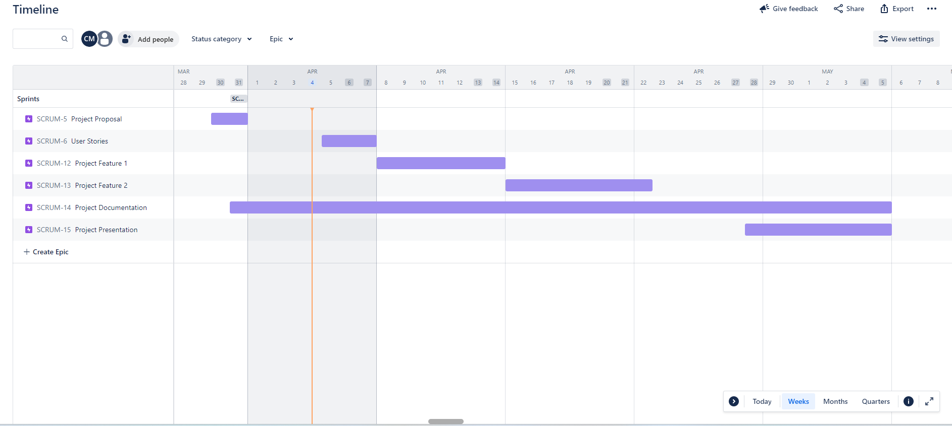

Figure 1. Jira Timeline Showing Scrum Sprints

## References

<https://orders2.me/the-4-most-common-problems-with-online-ordering/>

<https://medium.com/@OnlineEmenu_RestaurantSoftware/how-to-fix-the-5-most-common-problems-with-online-food-ordering-cf6d5bc8176f>

<https://www.lightspeedhq.com/blog/online-ordering-statistics/>